How to transfer files from iCloud to Google Drive

For the longest time, many of you must be thinking is this even possible? And after reading the title, your first reaction would be “Woah! Is it true?” Well, yes it’s very much possible to sync between the two platforms.  Now you must be really curious to know "How to do it?" In this post, we would cover all the aspects related to this process so keep reading.

## WHY??

Before jumping directly into “How to do it?” We’ll try to find out why some users feel the need for the data transfer from iCloud to Google Drive. The prime reason is the 15GB of free storage that Google offers as compared to the 5GB provided by Apple. The wide margin between the two platforms is the possible reason why the users would want to split some of the data from the Apple cloud to Google Drive.

While the USP of Apple is its novelty and tight integration, the Google boasts on its easy accessibility. To elaborate this let’s take an example. If you own more than one Apple device you probably know that they all share the same iCloud account corresponding to your Apple ID. So, if you have some crucial documents you can keep it on iCloud. You can consider Google Drive if you want some data that needs to be accessible and need to be shared frequently. So this way you get advantages of both the platforms.

## How??

The files from iCloud can be shared to Google Drive using Files App (Default app). Before transferring the data from iCloud to Google Drive first will bridge the gap between the two platforms. Then will look into the process copying of files.

### How to bridge the gap?

1. Install the Google Drive app (if not installed) on the iPhone.

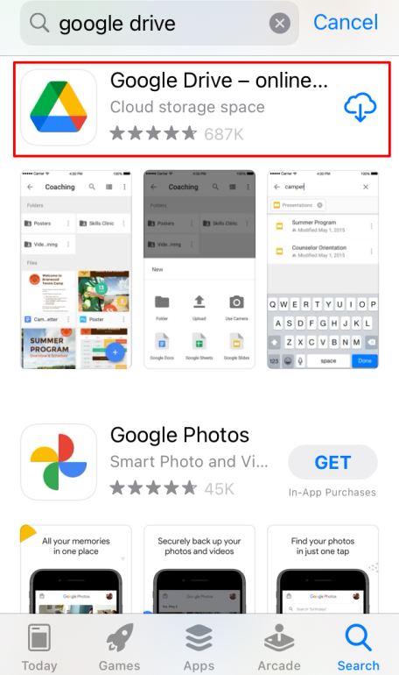

1. Tap on the Google Drive icon and sign in using your credentials.

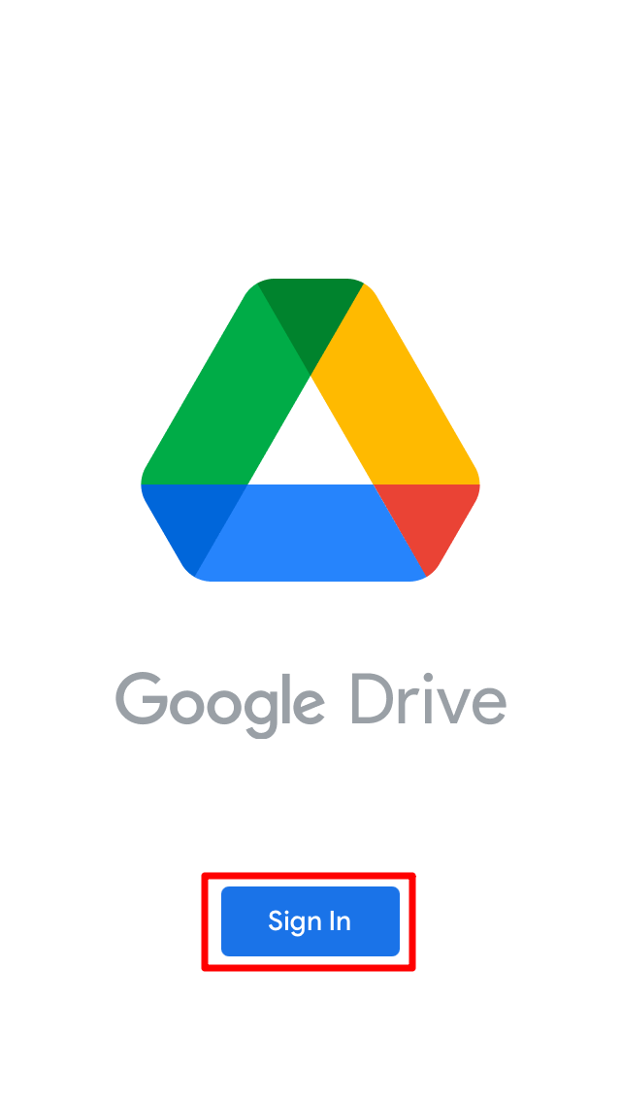

1. Open the Files App on the iPhone.
2. Click on the ***icon*** in the top right corner.

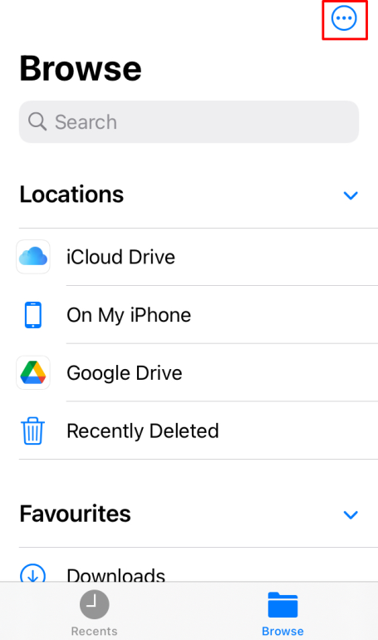

1. Click on ***Edit*** option.

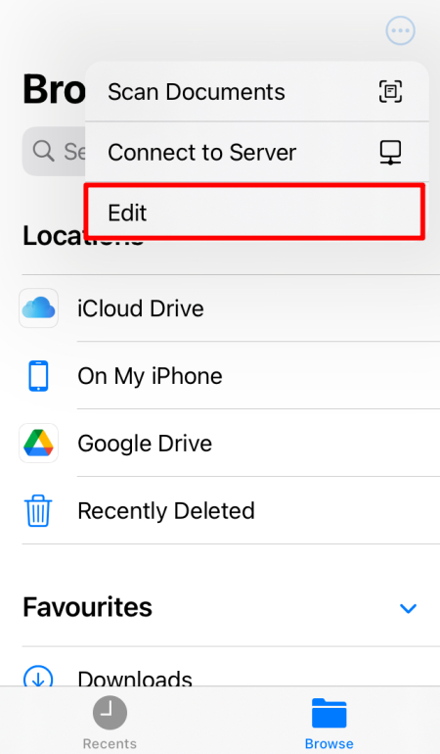

1. Toggle on the Google Drive on the screen and click ***Done***.

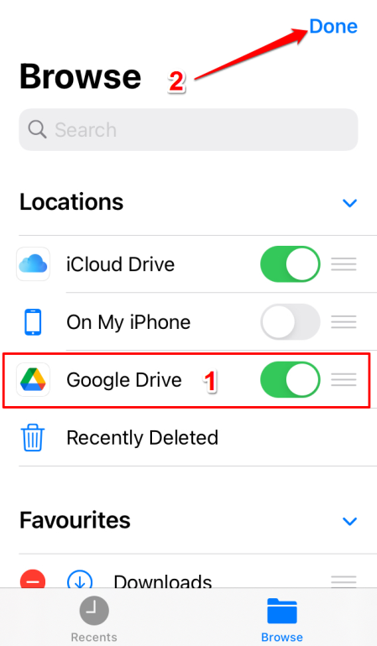

1. Click on Google Drive app from the Files App. But first authenticate then move to the next step.

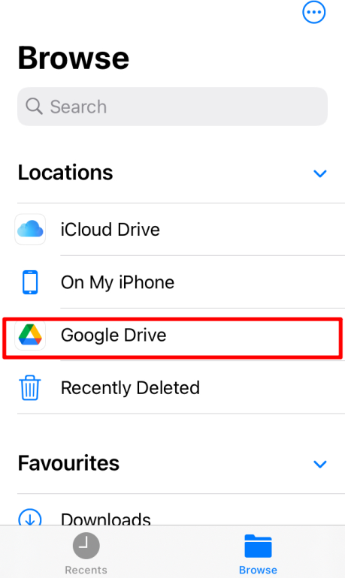

### Copying the files

1. Long press on the file you want to move to Google Drive and click ***Copy***.

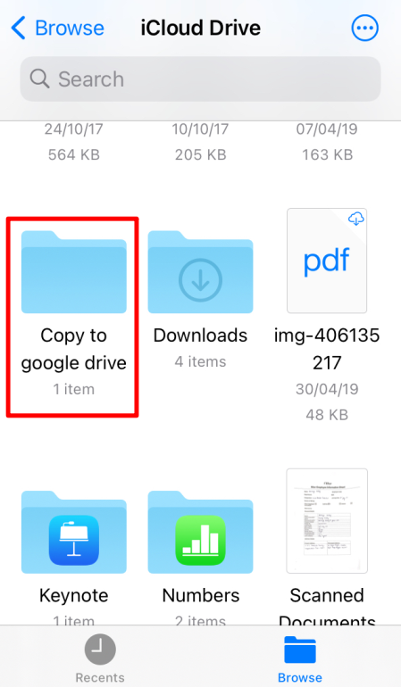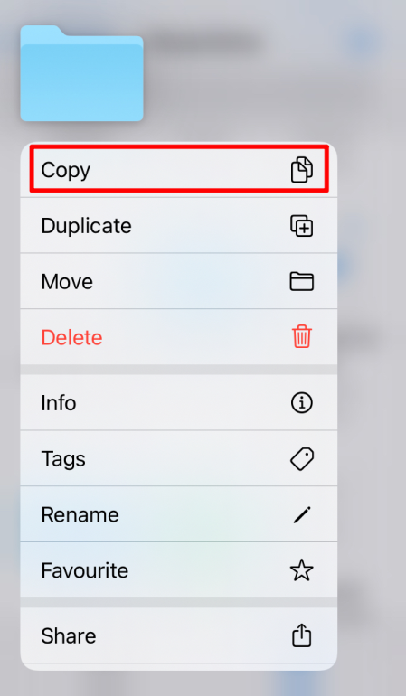

1. Go back to the main screen and tap Google Drive icon.
2. Long press any blank space you find on the screen. Scroll down a bit if you don’t find any space.
3. Click on ***Paste***.

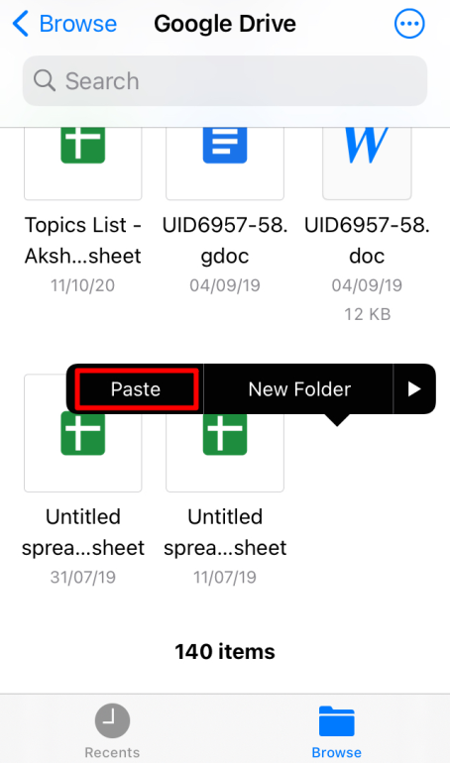

1. You can cross check to find file is synced or not.

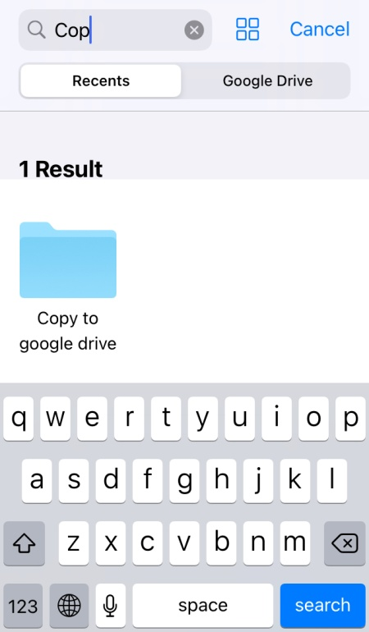

And you’re done!! The sync will happen in no time using these steps. You can take help if you want to transfer the files from Google Drive to iCloud/iPhone storage.

Hope this article helps you in solving your queries. Do let us know your thoughts/queries on this hidden feature in the comment section.